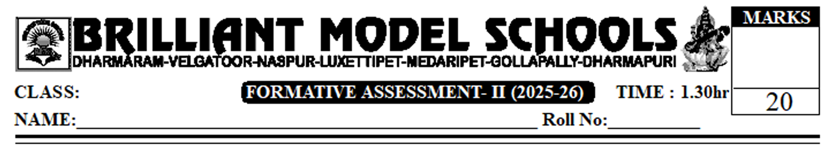
VII Social
I. Answer the following questions. 2x2=4
1. Name the important crops of southern Europe?
2. Name the two large deserts of Africa?
II. Answer the following questions. 2x3=6
3. A) How can you say that the slave trade is highly heinous? (or)
B) What are the stages of weaving sarees?
4. A) What is meant by Industrial Revolution? (or)
B) What do you understand the problems of weavers?
III. Observe the following table carefully and Answer the questions? 4x1=4
 | Raw Materials | Tools
Basket Making | Wild date plam leavesCaneBamboo | Knife
Handloom Wearing | Silk yarmDyeing cottonThread | Wooden LoomSmall KnivesMagginBobbin

1. List the raw materials used to make baskets?
2. What are the raw materials used to make Ikkat sarees?
3. Where are basket-making raw materials found?
4. How do weavers get silk yarn?
IV. Map pointing: Locate the states under given India map. 4x1/2=2
1. Locate the following parts.
a) Goa | b) Arunachal pradesh. | c) Ladakh | D) Kerala.
PART - B.
V. Choose the correct answer. 8x1/2 = 4
The inventor of Aeroplane in the early period of 20th century. ( )
A) George Stephenson. | B) Wright Brothers | C) Braganza Brothers | D) William Brothers.
The Biggest Lake in the world? ( )
A) Superior | B) Baikal | C) Caspian Sea | D) Black sea
3. The Largest sand desert in the world? ( )
A) Kalahari | B) Thar | C) Sahara | D) Pacific ocean
4. The Highest Peak in Africa? ( )
A) Meckenlee | B) Everest. | C) Kilimanjaru | D) Sahara
5. Ikkat means? ( )
A) cloth is dyed after weaving on looms
B) cloth is dyed after weaving
C) Never dyed
D) None.
6. Pochampally is in which district? ( )
A) Yadadri | B) Medak | C) Ranga Reddy | D) Hyderabad
7. Labour fought for these? ( )
A) civil rights | B) Construction of houses. | C) improvement in the conditions of Labour.
D) All the above.
8. The steam engine was invented by? ( )
A) Copernicus | B) John Gutenberg | C) James Watt | D) Boulton
PAGE NO: 1

PAGE NO: 1
PAGE NO: 1
PAGE NO: 1
PAGE NO: 1

PAGE NO: 1

PAGE NO: 1

PAGE NO: 1

PAGE NO: 1

PAGE NO: 1

PAGE NO: 1

